****Cainta Catholic College

A. Bonifacio Avenue, Cainta, Rizal

S.Y 2023-2024

**My Portfolio Website**

Mico Vicencio

BSCS3 – A

**Website Description:**

This portfolio website is a showcase of my skills and work as a developer. Built with HTML, CSS, and JavaScript, it highlights my projects, certifications, and background in a single, minimalist layout. You’ll find sections dedicated to my certifications, an 'About Me' overview, and a project gallery, as well as a contact form that uses EmailJS to handle form submissions, allowing visitors to contact me directly and ensuring I receive notifications. Designed without excess animations, the focus here is on functionality and clarity, aiming to attract potential clients and collaborators who appreciate clean, effective design.

**URL of the Website:**

[**https://micovicencio.github.io/portfolio/**](https://micovicencio.github.io/portfolio/)

**Screenshot of Website:**

**Landing Page**

**About me**

**My Projects**

**My Certificates**

**Contact Form**

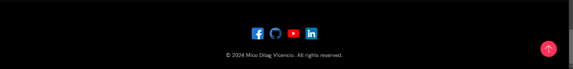**Footer**